**Employee Leave Management Related Analysis**

Employee Leave Management System allows to define employee’s allocated leave, leave type so that we can track the leaves and plan the payroll accordingly. Following image has four tables which we will be using to analyze and visualize what kind of questions we can expect from the business stakeholders.

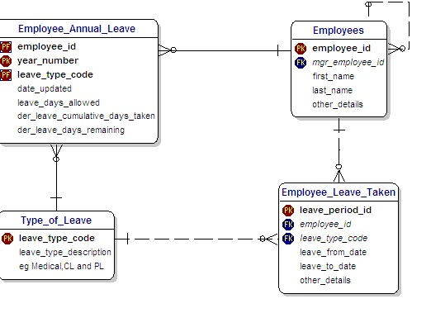

Which table will have the most number of records?

Which table will have the least number of records?

If we have 1000 employees and we are running the company from last 4 years, how many records you will have in employee_annual_leave table?

When do you update the information of cumulative_days_taken and leave_days_remaining in employee_annual_leave table?

If an employee applies for a sick leave for a day, what specific values goes into leave_from_date and leave_to_Date.

Write a query to show the employee name (firstname concatenate with last name with a comma in between first name and last name, year, leave_type_description, laves_allowed and number of leaves taken in each year.

Which table can be classified or referred as summary table in the above model?

Create a view called emp_leave_details and emp_leave_summary.   
**Emp_leave_details should have the following information**emp_id, emp_name (first name concatenate with last name), leave_type_desc, leave_from_date, leave_to_dates, no_of_days_leave (formula is leave_to_Date – leave_from_date).

Emp_leave_summary should have the following information  
emp_id, emp_first_name, emp_last_name, leave_type, number_of_leaves_allocated, number_of_leaves_taken, remaining_leave_days.